**DevOps Entreprise Summit London June 5th and 6th**

**CULTIVATE DEVOPS @ORANGE**

**(pitch : on going version June 1st Version)**

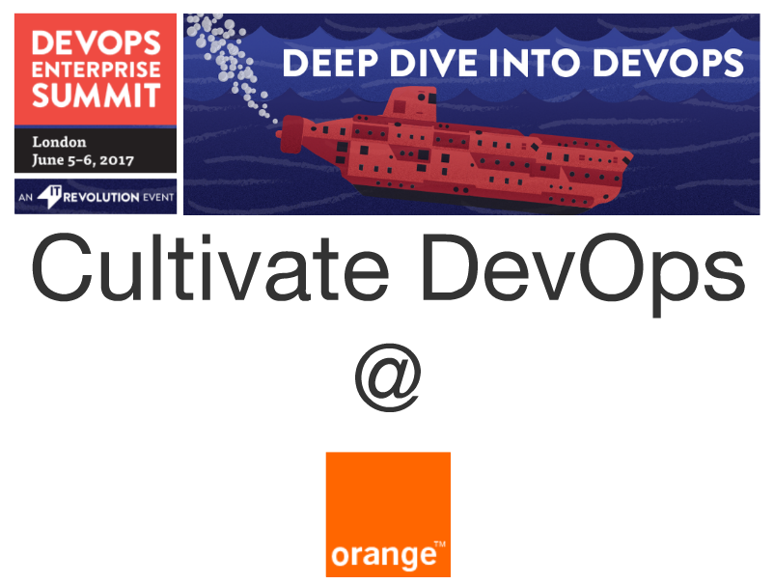

**NEXT**

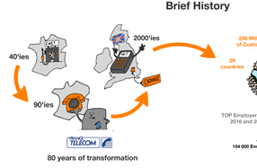

**NEXT**

Since the creation of French Telecommunications Research Center (CNET) in the 40’s, transformation is in our DNA.

**NEXT**

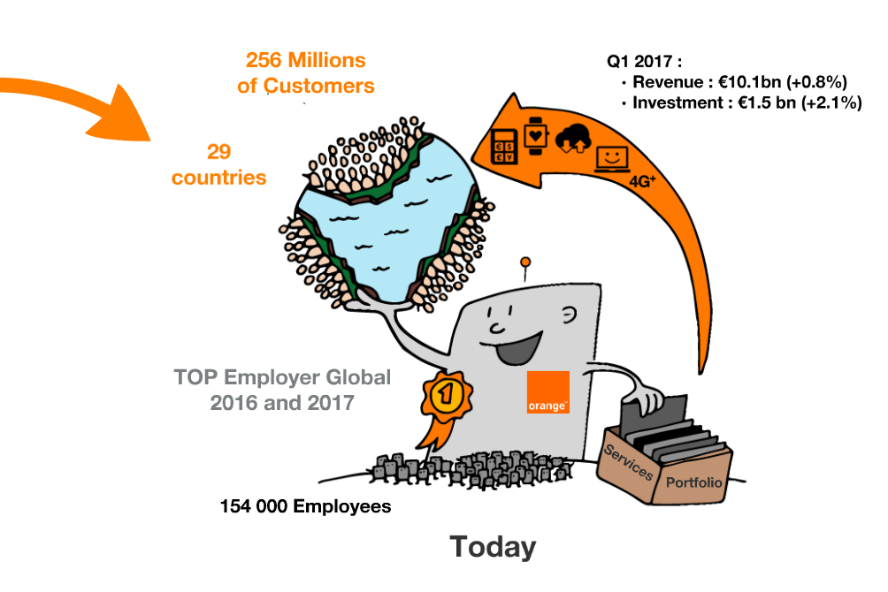



Our employees are continuously renewing our portfolio to serve



our customers using Orange as a single brand



over the world and respecting our cultural diversity.



And we are now offering a huge range of services from high speed Internet for all, to Mobile banking.

**NEXT**

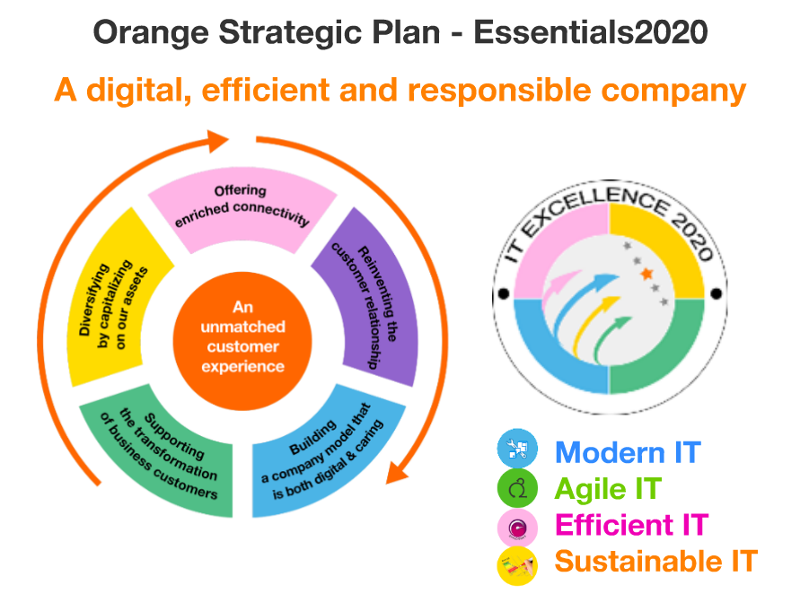

Our strategic plan called "Essentials2020" gives the direction :



be a digital, efficient and responsible company that offers



an unmatched customer experience.

And no unmatched customer experience without a modern, agile, and efficient IT.

Cloud Solutions, Agile and DevOps practices are the main enablers to reach that goal.

**NEXT**



We started our Devops journey with this vision. Sponsors and transformation leaders, communicated the « WHY » and the « WHAT ».

* WHY :
* 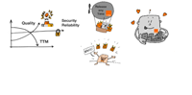

provide **top quality services** , reduce structural costs , ensure reliability and security (inc. data privacy) for our



**for all our IT applications** and meanwhile positively influence the lifes of



**all our IT people.**

* WHAT :



reach **collective agility** with **everybody** adopting agile and devops practices and tools with

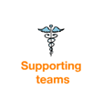

the supporting teams’ help

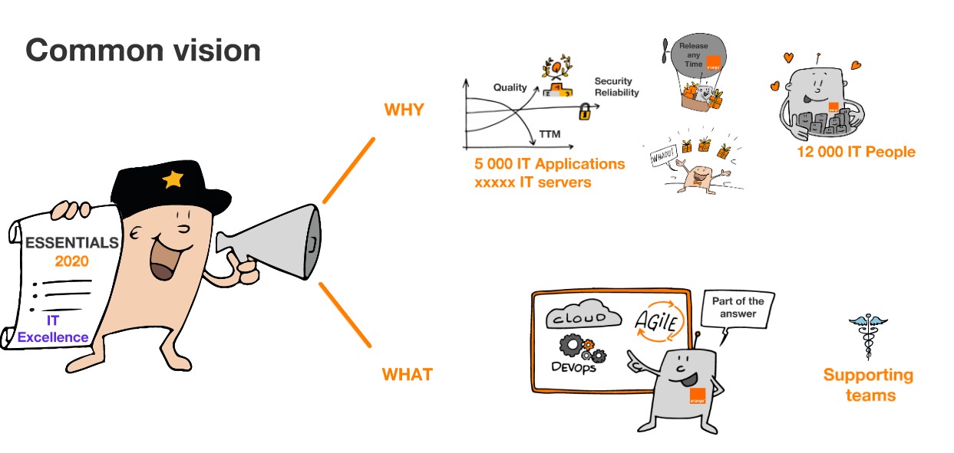

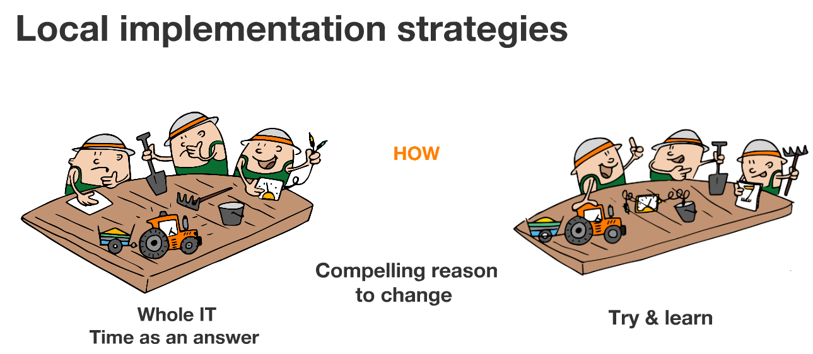

Taking into account existing culture, each business unit manages the HOW

but we are **all** using simple agile cultivation principles:

* Engage everybody around compelling reasons to make the change
* Decide where to invest first
* Try and foster continuous learning…

**NEXT**



We are now applying these simple agile cultivation principles in 10 countries.

And we’ve launched 45 pilots as first seeds, as diverse as possible

**NEXT**

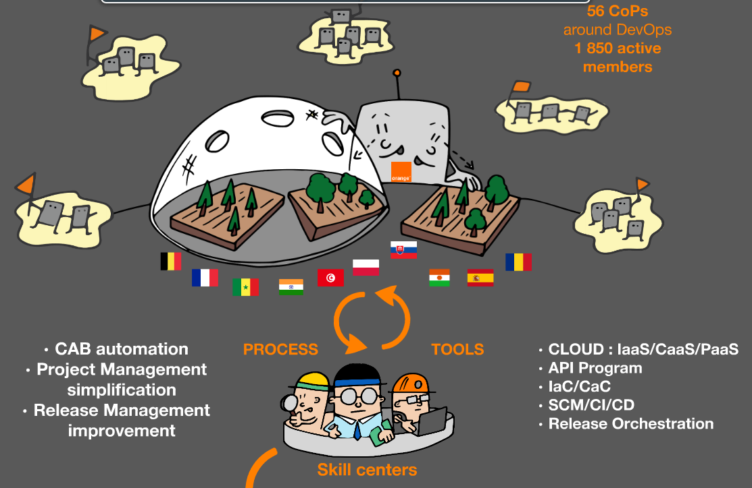

To optimize the learnings, we experimented in 3 main directions :

**1) We experienced new organizational models**

We settle incubators where biz dev and ops teams are jointly experimenting specific agile frameworks, adaptive governance, using new openspace technologies

**2) We experienced Tools.**

We reuse existing tools when appropriate; introduce new ones when it’s relevant. We pivot without mercy when feedbacks justify it.

**3) We experienced light weighted processes such as** Project and release management simplification Change Advisory Board automation

**NEXT**

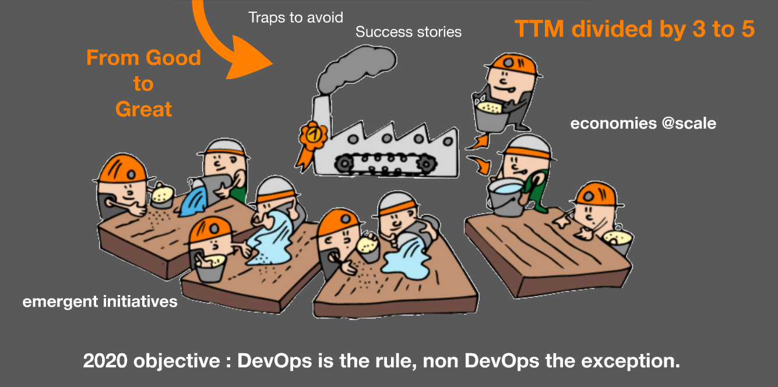

These experiments show us the first traps and also feed us with great success stories.

We standardize and industrialize reusable solutions and practices, when economies @scale justify it, without compromising new emergent initiatives.

**NEXT**

**Our objective: make DevOps become the rule within the whole IT in 2020**

**NEXT**

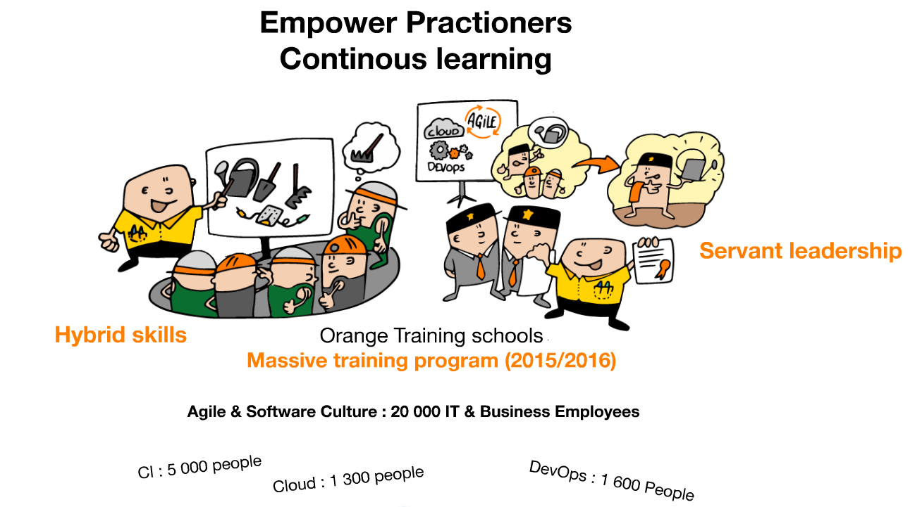

having hybrid skills is a key to reach this goal, a massive training program to have more T and Pi - shaped people, and more agile leaders was launched in collaboration with Orange Training schools.

**NEXT**

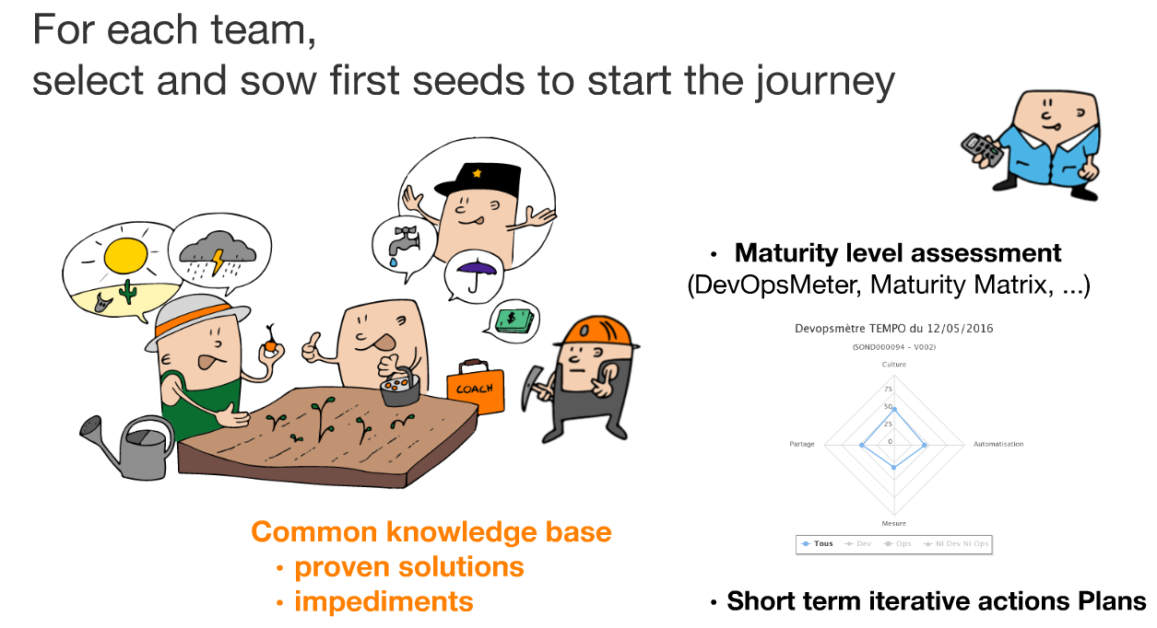

In addition to trainings, teams who need help to initiate their DevOps journey can rely on 100 coaches.

To ensure continuous learning, team members are invited to create a common knowledge base to capitalize and identify the major issues, in particular when scaling.

**NEXT**

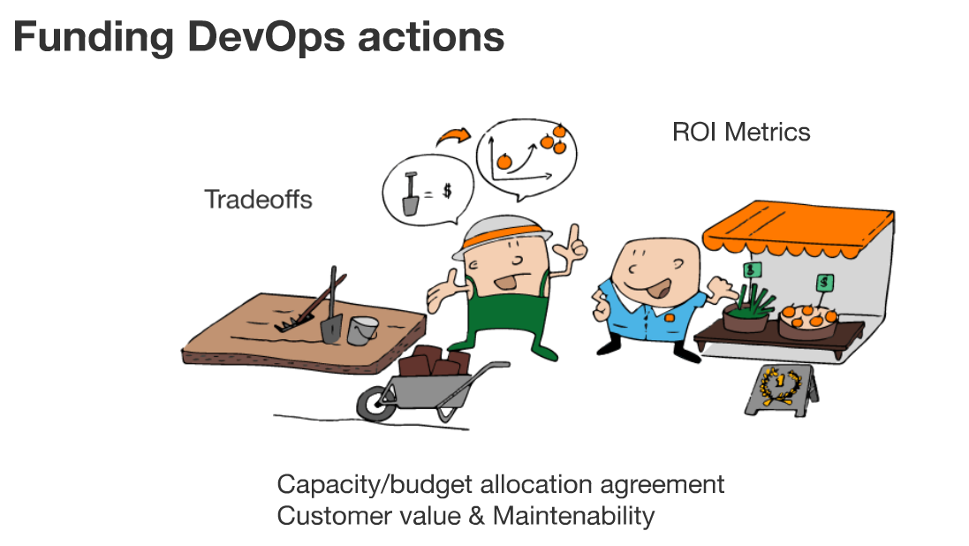

And when scaling we found out that funding is the first impediment.

Tradeoffs that maximize customer value without compromising maintainability and improvement are always needed. We have to transparently integrate transformation cost into business budget.

**NEXT**

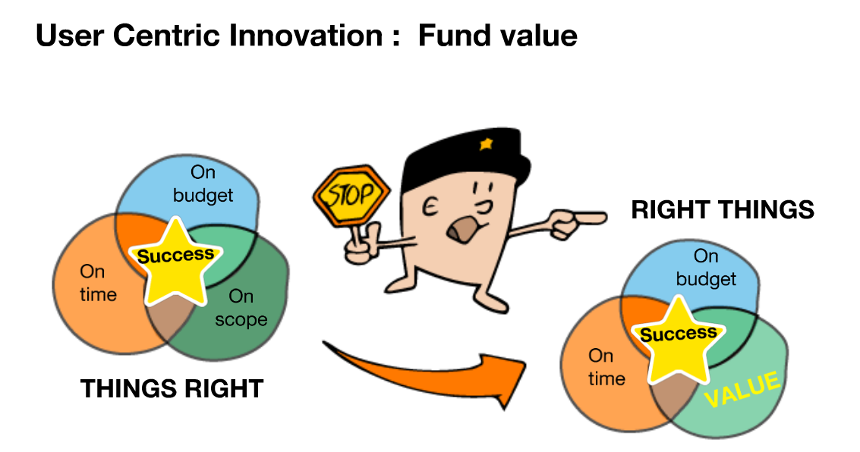

And User centric approach is leading us to fund value streams (instead of projects). It requires a significant change in our traditional stage-gated siloed processes In particular, the way we manage CAPEX and OPEX.

**NEXT**

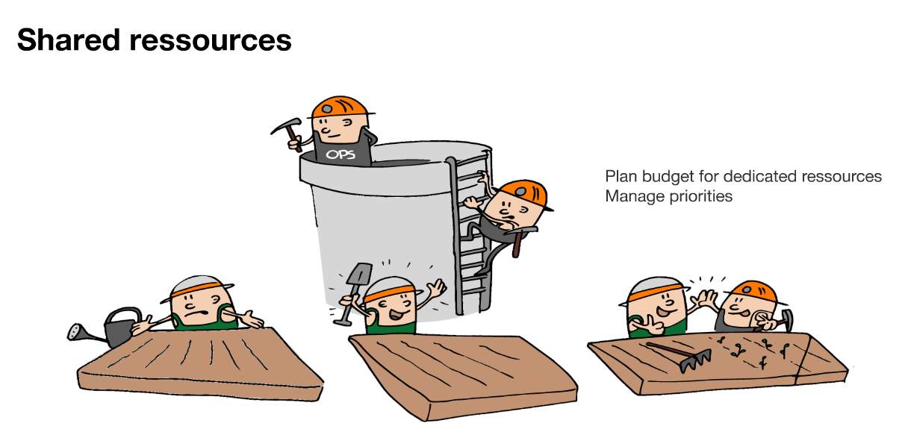

Last but not least, Dedicated Ops are needed to secure DevOps transformation whereas usually they are shared resource.

**NEXT**

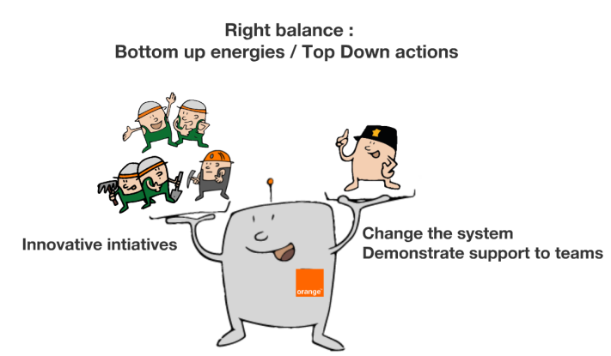

We discovered that 80% of teams’s brakes are generated by 20% of organizational causes, meaning under management responsibility. Right balance between Top down actions and bottom initiatives is a key success factor.

**NEXT**

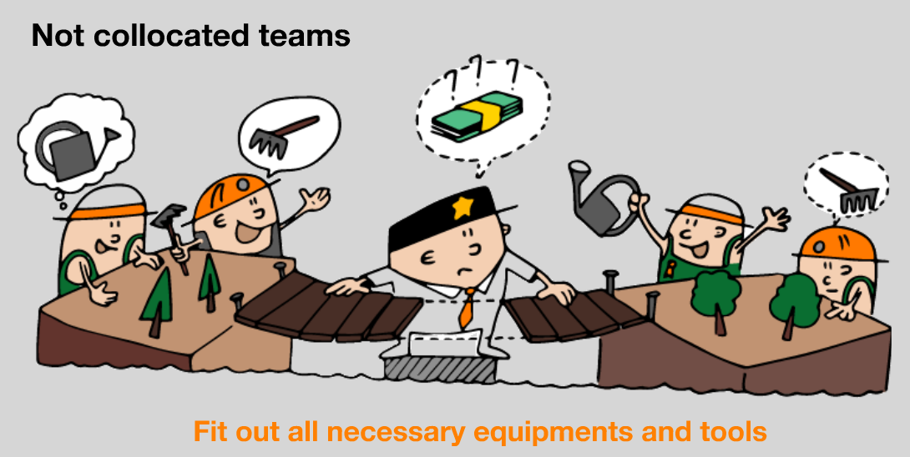

Change the habits and deeply anchor them takes at least 9 months, could be more when teams are not collocated. As it is our routine, all necessary equipment and tools to erase the distance have to be provided.

**NEXT**

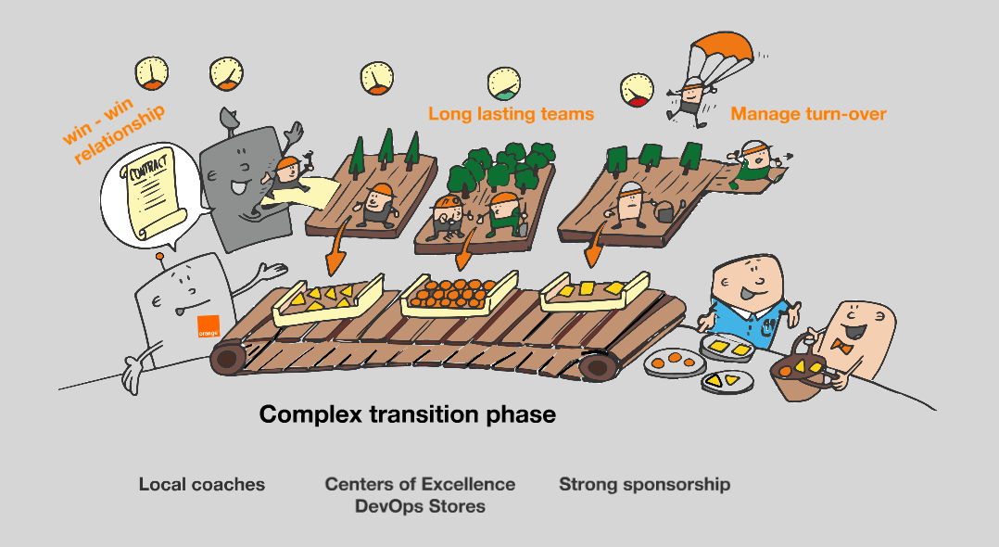

This point is the easiest to solve. We have others much more tricky:

* **we have to** reshape our contracts with our supplier and not only decide on pricing but also consider agile/devops maturity and build a win/win relashionship.
* We need long lasting teams, when ours are usually dissolved at the end of the projects.
* **and d**ue to our progressive and incremental approach, we have also to manage a complex transition phase.

As u can see, we still have a lot to do to become resilient to bad weathers, even to thunderstorms…

**NEXT**

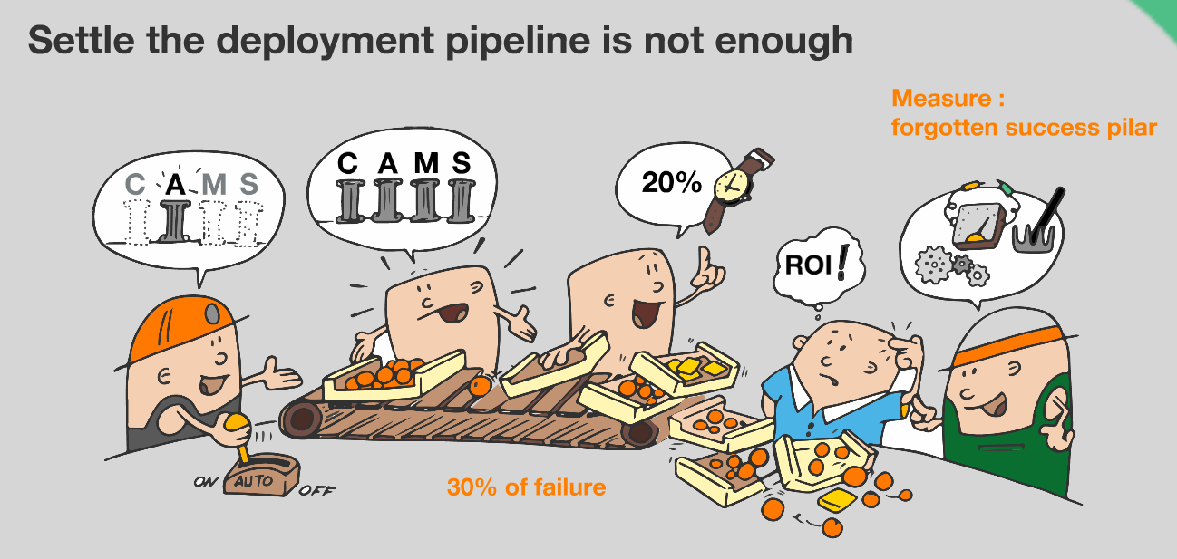

These thunderstorms happen when teams only focus on « automation ».

In technical company as Orange, automation is the easiest and fastest part of the game.

When some ingredients (involvement, alignment, measure, or sharing….) are missing, in 30% of the case, it is just a failure!

**NEXT**

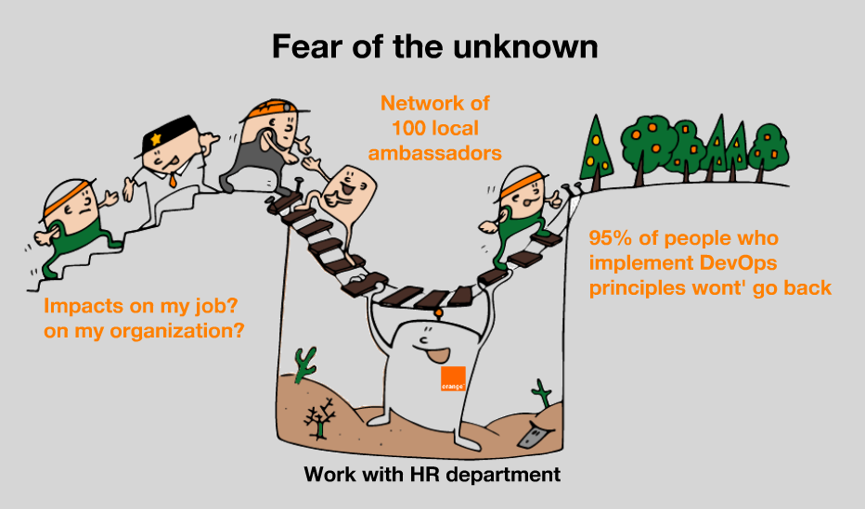

Actually tools are not a challenge for us our highest challenge is “human”.

We are working with HR departments, and workers representatives as we want to embark everybody

**NEXT**

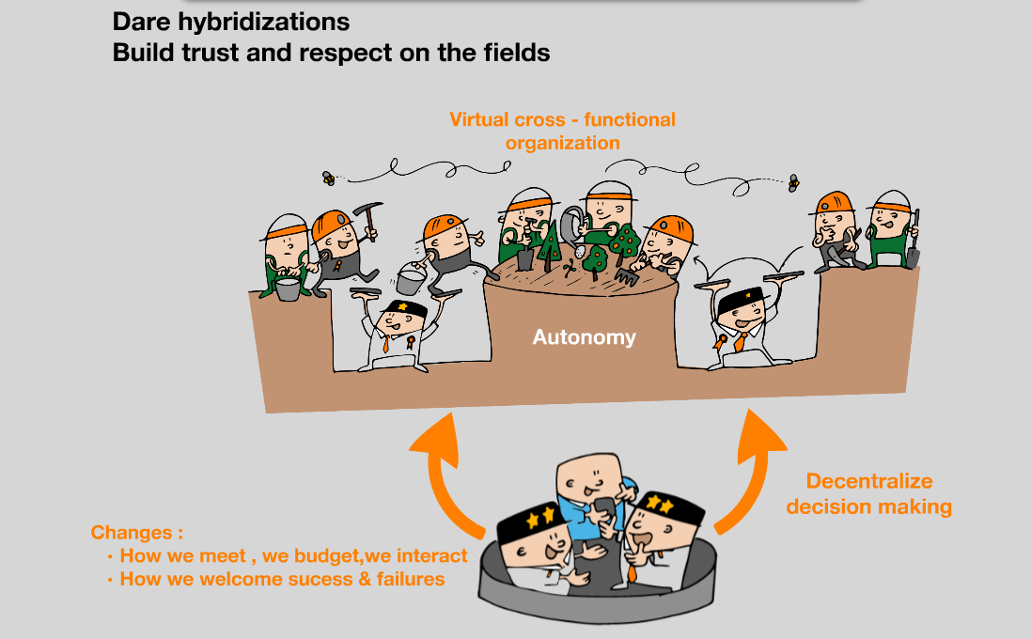

As you can see, DevOps is increasing our skills, it is also changing the way we budget, interact, welcome success and failures…and finally it is changing the culture...

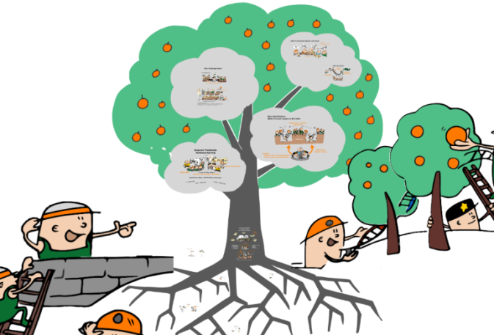

**NEXT**

We are sure that this new culture will allow us to retain our best talents and capture new ones. It will take time but the roots of these new trees are deeper and deeper anchored into the ground.

After just 18 months of DevOps journey in so large organization, the harvest has just started.

**NEXT**

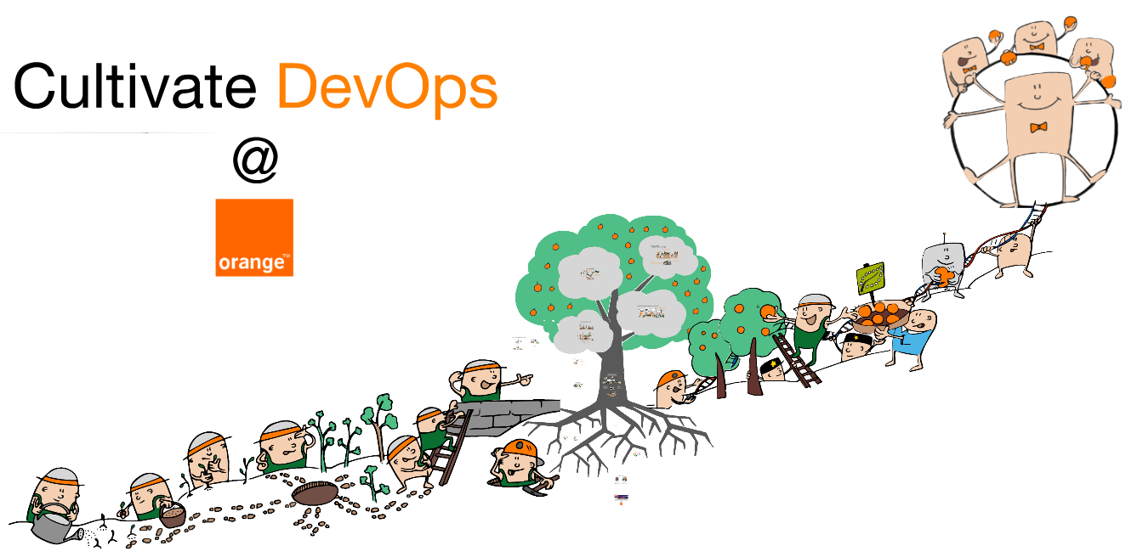

We are moving forward step by step, and the more we learn, the more we share, the more we are getting closer to the organic stage.

We have now to scale what works fine for IT teams to the entire company.

We’re convinced to be on the right way to transform every day, technology into progress as innovation only makes sense if it serves human being.

**NEXT (éventuellement en générique mais pas dans le déroulé)**

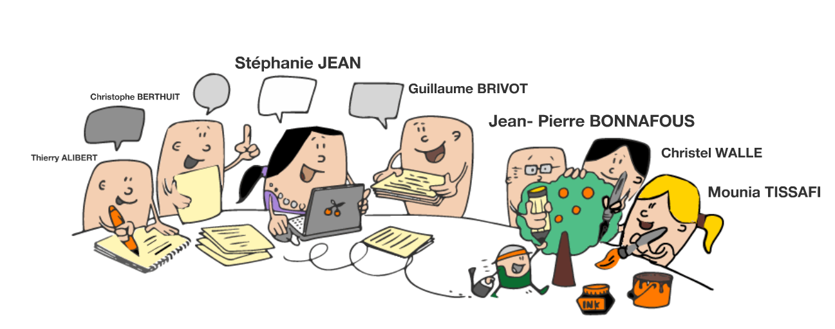

Thanks to the contributor + Berenger

entire version :

<https://www.youtube.com/watch?v=dArNAMQ3jfI>